Edco CPM 8

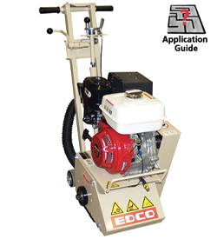
  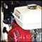
  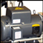
Features
- 8" working width will scarify approximately 350-500 sq. ft. per hour at Depth Per Pass of 1/8"
- Removes traffic lines at 800-1,000 lineal ft. per hour
- Power source over drum to eliminate vibration and maximize surface contact
- Compact design
- Front-mounted lifting handle makes loading and unloading easy
- Vacuum port equipped
- Water misting system standard
- Optional edger attachment allows the CPM-8 to get within 1 3/4" of any vertical surface
Ideal for:
- Sidewalk trip hazard repair
- Concrete and coatings removal
- Floor cleaning and/or preparations
- Creating non-slip surfaces
- Traffic line and markings removal

Model | Part # | Power | Horse Power | Phase | Amps | * RPM's | Belts | Length | Width | Height | Weight
CPM-8-5B | 79500 | Electric | 5 HP 230 V | Single | 19.5 | 2130 | Std. "V" Belts | 35" | 20" | 39" | 220 lbs.
CPM-8-5B | 79400 | Electric | 5 HP 230/460 V | Three | 12/6 | 2130 | Std. "V" Belts | 35" | 20" | 39" | 220 lbs.
CPM-8-9H | 79300 | Gasoline | 9 HP | NA | NA | 2150 | Cgd. "V" Belts | 35" | 20" | 39" | 190 lbs.

